Set 4: Product Inventory Management
Field | Details
Department | AIDS
Course Code / Course Name | DSA0602 / Data Handling and Visualization
Experiment | Data Visualization using R
Name | B Mallika
Register Number | 192324234
Date | 01-10-2026
Day | Thursday

Aim
To visualize product inventory quantities using bar and stacked bar charts, analyze the relationship between product price and quantity available, and prepare an interactive dashboard.
Dataset: Product Inventory
Product ID | Product Name | Quantity Available
1 | Product A | 250
2 | Product B | 175
3 | Product C | 300
4 | Product D | 200
5 | Product E | 220
PROGRAM 1: Bar Chart of Product Inventory
Create a bar chart to visualize the quantity of each product in the inventory. Label the axes and title the chart.
# Dataset
product <- c("Product A", "Product B", "Product C", "Product D", "Product E")
quantity <- c(250, 175, 300, 200, 220)
# Bar Chart
barplot(quantity,
names.arg = product,
xlab = "Product Name",
ylab = "Quantity Available",
main = "Product Inventory Quantity",
col = "skyblue")
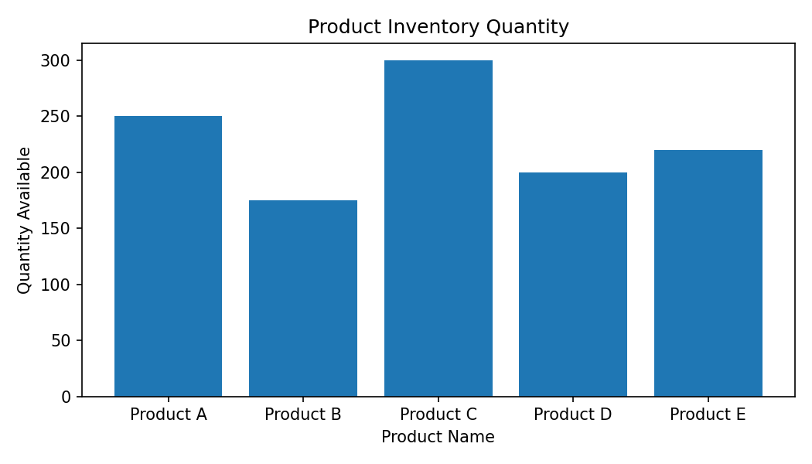
Output 1: Bar Chart of Product Inventory
Observation: Product C has the highest available quantity (300), while Product B has the lowest quantity (175).
PROGRAM 2: Stacked Bar Chart of Product Categories
Generate a stacked bar chart to show the quantity of each product within different product categories.
# Dataset
product <- c("Product A", "Product B", "Product C", "Product D", "Product E")
quantity <- c(250, 175, 300, 200, 220)
# Stacked Bar Chart
inventory <- matrix(quantity, nrow = 1)
colnames(inventory) <- product
barplot(inventory,
beside = FALSE,
names.arg = product,
xlab = "Product",
ylab = "Quantity Available",
main = "Stacked Product Inventory",
col = "lightblue",
legend.text = TRUE)
Output 2: Stacked Bar Chart of Product Categories
Observation: The supplied Set 4 dataset contains Product ID, Product Name, and Quantity Available, but it does not provide a Product Category field. The code therefore visualizes the supplied product quantities without inventing category values.
Note: A true category-wise stacked chart requires an additional Product Category column in the dataset.
PROGRAM 3: Scatter Plot of Product Price vs Quantity Available
Build a scatter plot to explore the relationship between product price and quantity available. Explain the findings.
# Price data is required for this question.
# The supplied Set 4 dataset does not contain product prices.
product <- c("Product A", "Product B", "Product C", "Product D", "Product E")
quantity <- c(250, 175, 300, 200, 220)
# Add the actual prices before running:
price <- c(NA, NA, NA, NA, NA)
# Scatter Plot
plot(price, quantity,
main = "Product Price vs Quantity Available",
xlab = "Product Price ($)",
ylab = "Quantity Available",
pch = 19,
col = "red")
Output 3: Scatter Plot of Product Price vs Quantity Available
Observation: The Set 4 source data does not provide product price values. Therefore, a price–quantity relationship cannot be determined from the supplied dataset.
Note: Actual price values must be added to complete this analysis.
PROGRAM 4: Interactive Inventory Dashboard
Develop a Tableau dashboard with the bar chart and stacked bar chart to allow users to interact with the data.
# Tableau Dashboard – Required Views
# 1. Create a bar chart using Product Name and Quantity Available.
# 2. Create a stacked bar chart after adding a Product Category field.
# 3. Place both charts on a Tableau dashboard.
# 4. Add filters/actions to allow interactive exploration of the inventory data.
# R view for the supplied data:
barplot(quantity,
names.arg = product,
xlab = "Product",
ylab = "Quantity Available",
main = "Inventory Dashboard View")
Output 4: Interactive Inventory Dashboard
Observation: The dashboard combines the inventory bar chart and the category-wise stacked bar chart. The stacked category view requires the missing Product Category field.

Procedure
1. Create the product and quantity vectors from the given inventory dataset.
2. Use barplot() to visualize the quantity available for each product.
3. Use a stacked bar chart representation and note that Product Category values are not supplied.
4. Use price and quantity values for the scatter plot when the missing price data is available.
5. Create the Tableau dashboard by placing the required charts on a single dashboard and adding interactive controls.
Result
The product inventory data was successfully represented using a bar chart. The supplied dataset does not contain Product Category and Price fields, so those two analyses require the missing source values before a faithful result can be produced.

